Maguwu fears for his life

Newsday News by Kenneth Nyangani

18 July 2022

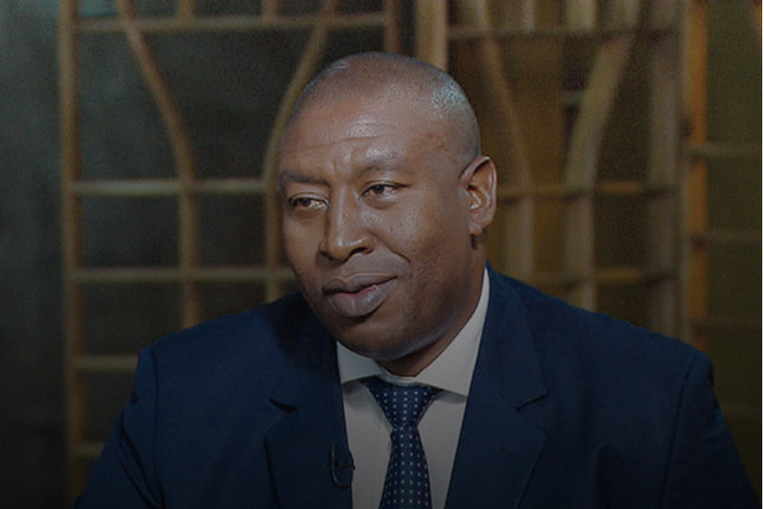

Farai Maguwu, director of the Centre for Natural Resources Governance

ZANU PF functionaries are reportedly baying for Farai Maguwu’s blood, with the human rights activist claiming that he recently received death threats for exposing gold looting ostensibly orchestrated by some ruling party bigwigs.

The Centre for Natural Resources Governance (CNRG) director Maguwu recently launched a 35-page report which exposed President Emmerson Mnangagwa’s ally Scott Sakupwanya being at the centre of gold leakages and violence at Redwing Mine in Penhalonga where more than 1 000 small-scale miners are currently operating.

Sakupwanya runs the Betterbrands Gold Mining Company which has a tributary agreement to mine gold at Redwing Mine. The mine is managed by Prime Royal Mine, a company owned by Prime Royal Africa Investments.

Maguwu yesterday said he received death threats from Chegutu West MP Dexter Nduna on Twitter.

“It’s very unfortunate that after the report, I have received deaths threats from Chegutu West MP Dexter Nduna on his Twitter (handle). I want to make a police report over the matter because I am taking it seriously,” Maguwu said.

The alleged threat read: “He should be patriotic and happy to avoid early recall. Anger gnaws at your vitals and leads to early deaths.”

In an interview yesterday, Nduna said he was not aware of the death threat made against Maguwu.

“I am not God, I don’t even know the person, he should first call me, (what) is the point of meeting him,” Nduna said.
Meanwhile, Civil Society Organisations have claimed that gold leakages and illegal gold mining have become a security threat by attracting criminals from beyond Zimbabwe’s borders.
During a Parliamentary Committee on Defence, Home Affairs and Security tour in Manicaland, it was also revealed that the sector would soon create well-funded “warlords”.
The committee toured the gold-rich Penhalonga and diamond-rich Marange areas.
Maguwu said warlords were created by having too many people making millions of dollars out of the informal sector.
“Illegal gold mining is now the main economic activity in the country and is politically organised. The violence and criminality in the sector is growing and the political connections make the sector ungovernable,” Maguwu added.
https://www.newsday.co.zw/2022/07/maguwu-fears-for-his-life/

To read the full illegal gold mining report:
https://www.cnrgzim.org/_files/ugd/e33f9c_0f8d4cd7506c44ffb6aa45624fb1be88.pdf?index=true

